Emails
Eventually send out templated from code

Scheduling The First Meeting

V1
Title: Unlocking the Potential of Your Online Presence
Hello [Client Name],
I'm eager to connect with you and discuss your needs and requirements. Could you please share your availability for the next couple of weeks? I'd like to coordinate a time that works best for both of us.
I've proposed a few time slots below; let me know if any of these work for you. Anticipate our meeting to last around an hour, potentially longer:
- Wednesday at 3:00 pm
- Thursday at 11:00 am
- Friday at 10:30 am
Once we finalize our meeting time, I'll follow up with additional details on what to expect when working with me. This will include insights into the process we'll embark on to maximize throughput efficiency, streamline collaboration, and, most importantly, turn your vision into a vibrant reality. I am committed to ensuring that your dream website becomes a powerful tool for expanding your online presence and customer base.
Looking forward to our discussion!
Best regards,
[Your Full Name]
[Your Contact Information]
[Logo]

Our Process - What to Expect
Title: Working With Expanse: What to Expect
Hello [Client Name],

To help you better understand my approach, I have outlined the key steps involved in working with me below. I will adjust the process according to your unique needs and project requirements. Please let me know if you have any questions!

We will embark on your digital journey with a comprehensive needs assessment, delving into your business goals and user needs. We then transform your vision into detailed wireframes and prototypes, bringing your ideas to life. Throughout the development process, we continuously adapt and fine-tune our approach, focusing on the most critical elements first. This ensures that your project remains on track and delivers the features and functionality you need to achieve your goals while minimizing risks, expediting time to market, and optimizing cost efficiency.

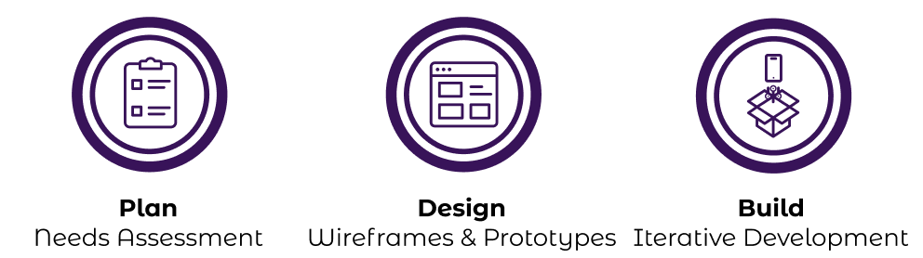
For more details on the full process check feel free to review the attached PDF or view it online here

Best Regards,
Matthew Mckeller

